PUBLIC NOTICE PRETREATMENT RATIONALE FOR ISSUANCE

NASA, John C Stennis Space Center

Hancock County

Stennis Space Center, MS

Water II Branch

MSP092488

SIC: 9661; 8744; 4953; 4952

July 13, 2026

Permit Engineer: Rusty Parrish

FACILITY INFORMATION

Nature of Business: Conduct research on ground and rocket systems for the U.S. Space Program.

Process Wastewater Description:

Outfall 101 consists of discharge from the 7-stage clean line process (Attachment A) for valves, fittings, and smaller components.

Outfall 001 consists of discharge from the current NPDES Permit No. MS0021610 Outfalls 001 & 002. The discharge from the NPDES permit will now be directed to new lift stations and sanitary sewer pipes. See Attachment B for a complete breakdown of the wastewater being discharged.

Note: Attachment C shows how the wastewater will be collected and directed to the Hancock County Utility Authority.

Proposed Flowrate:

Outfall 101 – 750 gallons per batch discharge (one discharge per month).
- Outfall 001 – 228,000 gallons per day = 0.228 MGD

- Applicable Federal Guidelines: 40 CFR Part 433 – Metal Finishing Point Source Category, specifically 433.17.

RECEIVING POTW INFORMATION

POTW Name, AI No., and Permit No.: Hancock County Utility Authority, Northern Regional WWTP; AI# 38603; MS0061239

POTW Treatment Type: Wastewater is treated biologically via oxidation ditch then UV disinfection.
- POTW Design Flowrate: 1.5 MGD
- POTW Receiving Stream: Jourdan River
- POTW Receiving Stream 7Q10 (Q_{7/10}): 14.9 cfs = 9.63 MGD
- NOTABLE SAMPLING DATA FROM PERMIT APPLICATION 2P

Data is not available since the facility has not discharged, and the wastewater treatment system is not in operation yet.

- DEVELOPMENT OF CATEGORICAL LIMITATIONS

40 CFR Part 433 – Metal Finishing Point Source Category; Subpart A – Metal Finishing Subcategory.

The term “TTO” shall mean total toxic organics, which is the summation of all quantifiable values greater than 0.01 milligrams per liter for the toxic organics. A list of the toxic organics is provided in 40 CFR 433.11(e). For TTO monitoring, the permittee only needs to analyze for those pollutants which would reasonably be expected to be present. [40 CFR 433.11(e) and 433.12(a)]
The permittee may, in lieu of monitoring for TTO, submit a toxic organic management plan (TOMP) for review and approval. The TOMP must specify the toxic organic compounds used; the method of disposal used instead of dumping, such as reclamation, contract hauling, or incineration; and procedures for ensuring that toxic organics do not routinely spill or leak into the wastewater. Upon approval, the permittee may discontinue monitoring for TTO, but the following certification statement must be made in the comment section of every discharge monitoring report submitted:
"Based on my inquiry of the person or persons directly responsible for managing compliance with the permit limitations for total toxic organics (TTO), I certify that, to the best of my knowledge and belief, no dumping of concentrated toxic organics into the wastewaters has occurred since filing of the last discharge monitoring report. I further certify that this facility is implementing the toxic organic management plan submitted to the MDEQ." [40 CFR 433.12(a) and (b)]
40 CFR 433.17 – Pretreatment standards for new sources (PSNS)

Pollutant | Monthly average shall not exceed | Maximum for any 1 day
Pollutant | Milligrams per liter (mg/L)
Cadmium (T)* | 0.07 | 0.11
Chromium (T) | 1.71 | 2.77
Copper (T) | 2.07 | 3.38
Lead (T) | 0.43 | 0.69
Nickel (T) | 2.38 | 3.98
Silver (T) | 0.24 | 0.43
Zinc (T) | 1.48 | 2.61
Cyanide (T) | 0.65 | 1.20
TTO | N/A | 2.13
*The term “T” shall mean total. [40 CFR 433.11(a)]

In a letter dated August 19, 1998, the EPA states: “For effluent guidelines, for permitting under NPDES, and for other purposes in EPA’s water programs, the terms ‘total metal’ and ‘total recoverable metal’ may be used interchangeably…” . The metals will be permitted as total recoverable metals.

433.17(c) – Permittee shall not augment the use of process wastewater or otherwise dilute the wastewater as a partial or total substitute for adequate treatment to achieve compliance with the limitations above.

Calculated loads based on the permitted flowrate of 0.00075 MGD:

PROPOSED PERMIT LIMITATIONS
Internal Outfall 101

TR = Total Recoverable; BTJ = Best Technical Judgement

Cadmium (TR), Chromium (TR), Copper (TR), Lead (TR), Nickel (TR), Silver (TR), Zinc (TR), and Cyanide (T) shall be monitored monthly via grab sampling. TTO shall be monitored semi-annually via grab sampling . pH shall be monitored weekly via grab sampling. Flow shall be monitored once per discharge event via metering system.

TTO DMR (Discharge Monitoring Report) analyses shall be submitted semi-annually while all other parameters shall be submitted monthly.

Outfall 001

BTJ = Best Technical Judgement

Based on information provided by the facility, the majority of the wastewater being discharged through proposed Outfall 001 will be general purpose/ sanitary; therefore, flow will be the only limit for this outfall.

Flow shall be monitored daily via continuous recorder.

Due to lack of available data from NASA, categorical limits are being established for the initial issuance of this permit.

Within 12 months after permit issuance, the permittee shall submit a complete Pretreatment Form 2P application containing updated data derived from the permitted discharge. Based upon the results of the analyses, the permit may be reopened and reissued to reflect this data.

The permittee shall notify MDEQ within 7 days after the commencement of discharge from Outfall 001.

The permittee shall notify MDEQ within 7 days after the commencement of discharge from Internal Outfall 101.

Changes from first draft:
All parameters except for TTO for Internal Outfall 101 have a sampling frequency of once per discharge event instead of monthly. This is based off the comment letter received via email from the facility on June 9, 2026.

APPENDIX A

REMOVAL EFFICIENCIES

*Removal Efficiency = [(<inf.> - <eff.>)/<inf.>]*100, where <inf.> is the average influent value and <eff.> is the average effluent value.

Values obtained from POTW bench sheets. Literature Values are highlighted in orange.
Grey-shaded values were excluded because influent ≤ effluent for the same sample date.
Blue values were used in “non-detect” results in which the Method Quantitation Limit (MQL) was then divided by 2 to obtain the blue value.
**Appendix R of EPA’s Local Limits Development Guidance for tertiary treatment was used due to inadequate data from the POTW.

ATTACHMENT A
CLEAN LINE PROCESS (Outfall 101)
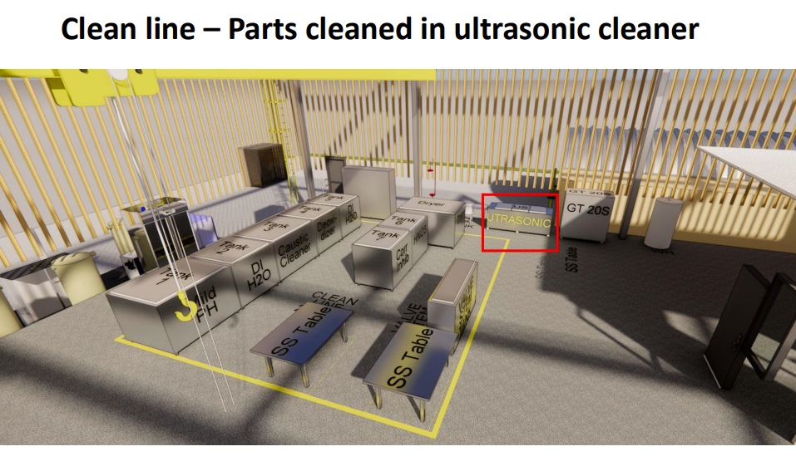
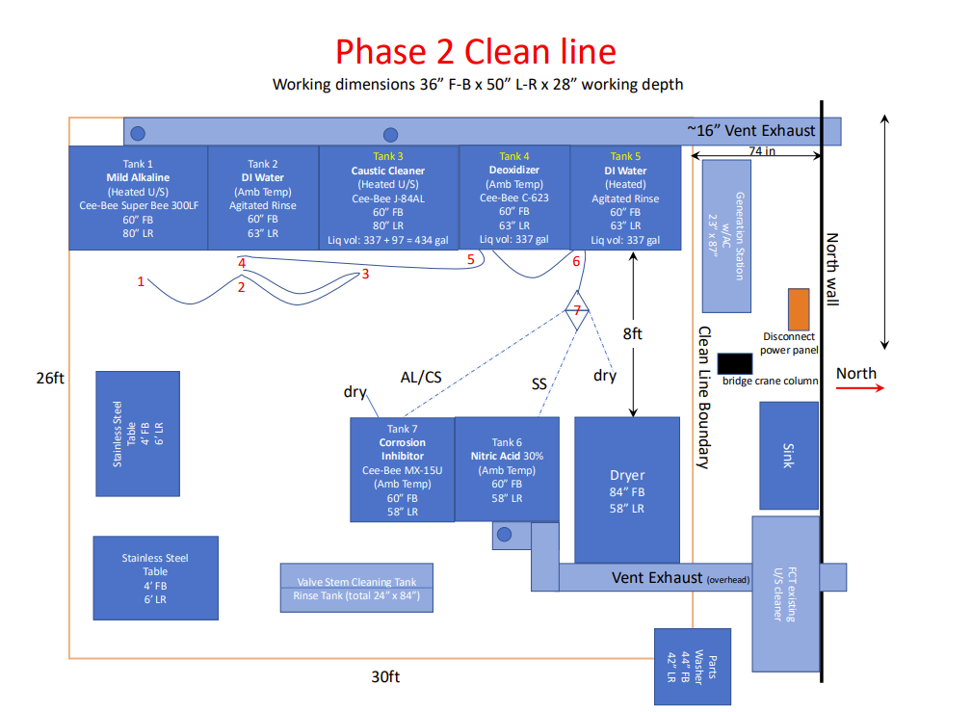
Valves, fittings, and smaller components will be processed through this clean line system. Tank 2 will contain residual cleaning fluid from Tanks 1 & 3 combined with deionized water. Tank 5 will contain a mixture of residual cleaning fluid from Tanks 4, 6, &7 combined with deionized water. After the cleaning, components will be air dried or dried using a mechanical drying unit. No discharge has occurred as of May 1, 2026, but once discharge occurs, Tanks 2 & 5 will be collected into an intermediate bulk container and analyzed to determine if further treatment is required prior to batch discharging to the sanitary sewer.

ATTACHMENT B

Current NPDES Permit No. MS0021610 Outfall 001:
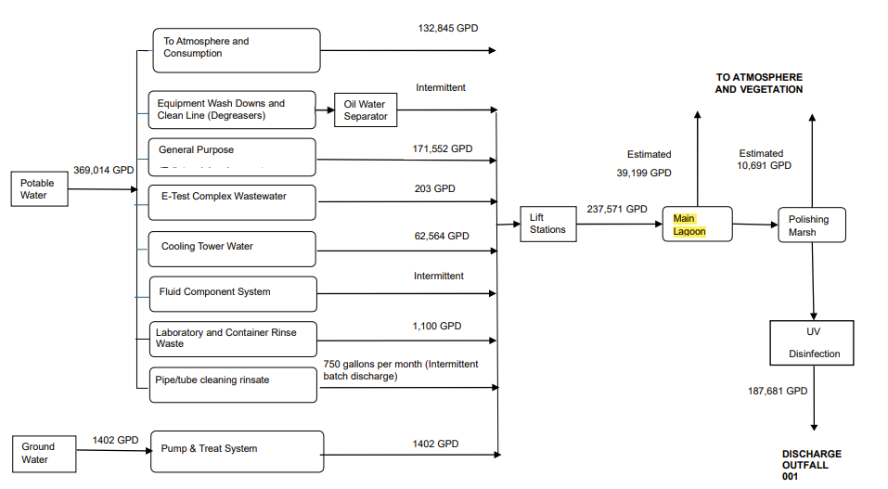
All the wastewater generated through this process will comingle with NPDES Permit No. MS0021610 Outfall 002 before discharging into the sanitary sewer line to the Hancock County Utility Authority. The highlighted “Main Lagoon” will be decommissioned after the issuance of Pretreatment Permit No. MSP092488 as stated by NASA via email on May 1, 2026.

Current NPDES Permit No. MS0021610 Outfall 002:
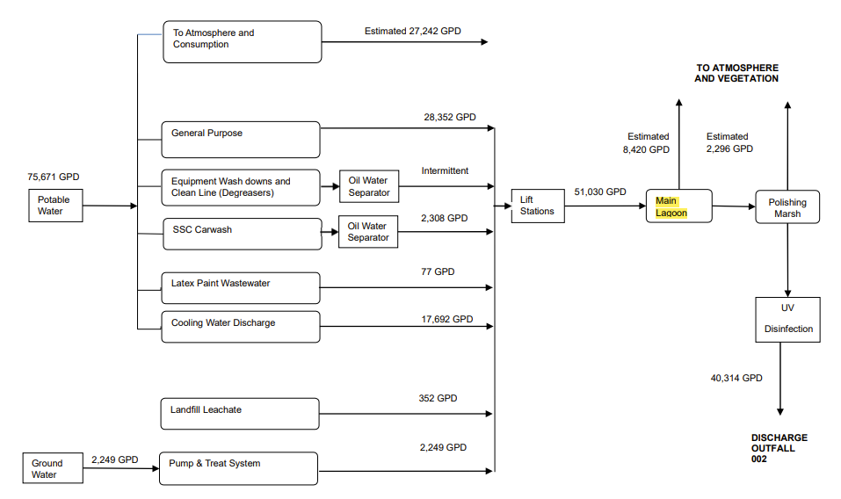

All the wastewater generated through this process will comingle with NPDES Permit No. MS0021610 Outfall 001 before discharging into the sanitary sewer line to the Hancock County Utility Authority. The highlighted “Main Lagoon” will be decommissioned after the issuance of Pretreatment Permit No. MSP092488 as stated by NASA via email on May 1, 2026.

ATTACHMENT C
WATER FLOW DIAGRAM

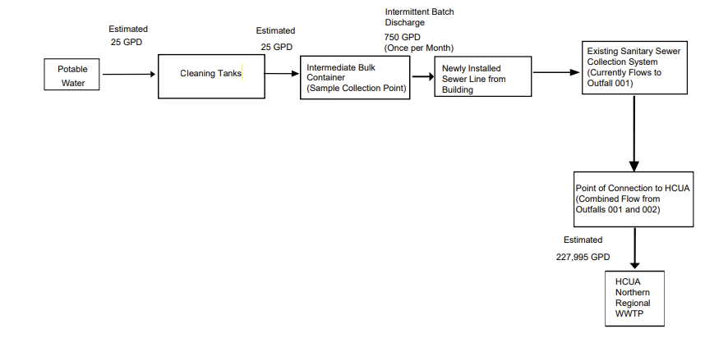
Internal Outfall 101 will be located at the “Newly Installed Sewer Line from Building” which is where sampling will occur. The effluent from Outfall 101 will go through the “Existing Sanitary Sewer Collection System” and begin to comingle with the untreated wastewater from NPDES Permit No. MS0021610 Outfalls 001 & 002 at the location “Point of Connection to HCUA”. Immediately after “Point of Connection to HCUA”, this will be the new Outfall 001 for Pretreatment Permit No. MSP092488.

ADEQUACY OF TREATMENT

Date: May 4, 2026
Permit Writer: Rusty Parrish

Site: NASA, John C Stennis Space Center
Pretreatment Permit No. MSP092488
Carroll County

Proposed Hydraulic Loading: 0.050 MGD Proposed Flowrate: 0.00075 MGD (Outfall 101) + 0.228 MGD (Outfall 001) = 0.22875 MGD
The proposed flowrate of 0.22875 MGD is less than the 1.23 MGD available; therefore, the POTW has sufficient hydraulic capacity to accept the proposed discharge.

