Pre-Construction Review

and

Preliminary Determination

of Approval for

Interfor US, Inc. – Bay Springs Division

Facility No. 1300-00019

Technical Review

by

Mr. Fisher Floyd

Air Quality Analysis

By

Mr. Rodney Cuevas

September 7, 2022

General Information
Interfor US, Inc. – Bay Springs Division (“Interfor”), located at 71 Georgia Pacific Road in Bay Springs, Mississippi 39422, (601) 452-7031 is an existing facility that currently operates a sawmill, a planer mill, and two (2) direct-fired lumber drying kilns (each equipped with a sawdust gasifier and a natural gas-fired burner). The facility’s overall operations fall under SIC Code 2421 (Sawmills and Planing Mills, General).
The facility has submitted a complete air permit application for a Prevention of Significant Deterioration (PSD) Permit to Construct to modify an existing batch lumber drying kiln to operate as “continuous”. Additionally, the facility is has requested that the existing dried lumber throughput limitation be increased from 170.6 million board feet (MMBF) per year to 230.0 MMBF per year.
The MDEQ received the PSD Construction Permit application on January 12, 2022. The MDEQ transmitted comments on the initial application to Interfor on March 9, 2022. As such, subsequent information was received on June 2, 2022, which included revised project-related emissions and the addition of applicable ozone monitoring data. Overall, the proposed project will result in the emission of volatile organic compounds (VOCs) at a rate that exceeds the significant emissions rate for ozone in Mississippi PSD regulations (Mississippi Administrative Code, Title 11, Part 2, Chapter 5), which adopt by reference the United States Environmental Protection Agency’s (USEPA) PSD regulations found in 40 CFR 52.21.

Project Description
Interfor is proposing to modify an existing batch direct-fired lumber drying kiln (Emission Point AB-002) to operate as a continuous drying kiln. As this modification will increase the kiln’s drying annual drying capacity, the facility is also requesting an increase in the lumber throughput limit from 170,600.0 thousand board-feet (MBF) per year to 230,000.0 MBF per year for all kilns combined. Therefore, both kilns are considered “modified” sources. Additionally, due to an evaluation of the process flow upstream and downstream of the modified sources, the following sources are considered “affected” sources: log sawing activities, debarking activities, bark hogging, green wood chipping, loading activities (for bark, green wood, and dry shavings), the sawmill, the planer mill, and the haul roads (both paved and unpaved).
Based on the affected sources for the proposed project, Interfor employed a hybrid applicability test to determine the overall project-related emissions increases that combines the “actual-to-potential” test for modified sources (i.e. the emissions increase is based on the source’s maximum potential capacity) and the “actual-to-projected actual” test for existing sources [i.e. the emissions increase is based on the regular operation of equipment in any one (1) of the (5) years after completing the project].
As a result of the hybrid applicability test, the overall project-related emissions increase only exceeds the SER for VOCs. However, the emissions increase for particulate matter (PM), particulate matter less than 10 microns in diameter (PM₁₀), and particulate matter less than 2.5 microns in diameter (PM_{2.5}) are at least fifty percent (50%) of the threshold for the corresponding SER threshold. As such, under the “Reasonable Possibly Rule” [40 CFR 52.21(r)(6)(vi)], Interfor will be required to calculate and maintain the annual emission (based on a 12-month calendar year basis) of the three (3) noted pollutants from all sources affected by the proposed project for a period of five (5) years after completing construction.
Additionally, as part of the subsequent information received on June 2, 2022, Interfor re-evaluated PM-related emissions from the cyclone attributed to the planer mill (i.e. Emission Point AB-005) on the basis of the maximum potential dried lumber throughput (as opposed to the maximum potential operational basis of 8,760 hours). From this re-evaluation, Interfor has determined that the PSD avoidance limits for Emission Point AB-005 in the PSD Permit to Construct issued August 16, 2018 are overly conservative and are no longer required. As such, the facility requested that the denoted limits be made non-effective. Upon review of the re-evaluation, the MDEQ concurs that the facility’s determination and has removed the limits.
Based on the proposed modifications, the facility will not be subject to any new Federal regulations.

Table 1. PSD Applicability
Pollutant | Project-Related Increases  (tpy) | Significant Emission Rate  (tpy) | Netting Analysis Required?  (Yes / No) | Contemporaneous Emissions  (tpy) | Total Net Emissions  (tpy) | PSD Review Required?  (Yes / No)
PM | 24.78 | 25 | No | 0.00 | 24.78 | No
PM₁₀ | 13.71 | 15¹ | No | 0.00 | 13.71 | No
PM_{2.5} | 7.171 | 10 | No | 0.00 | 7.171 | No
NO_{X}^{1,2} | 0 | 40 | No | 0.00 | 0 | No
SO₂¹ | 0 | 40 | No | 0.00 | 0 | No
VOCs² | 259.1 | 40 | No | 0.00 | 259.1 | Yes
CO | 0 | 100 | No | 0.00 | 0 | No
¹ As of April 28, 2011, both NO_{X} and SO₂ are precursors for PM_{2.5}. Therefore, if NO_{X} or SO₂ exceed 40 tpy, the project is considered major for PM_{2.5}.
² Both NO_{X} and VOC are considered precursors for ozone with a significant emission rate of 40 tpy each.

Best Available Control Technology (BACT) Analysis
In accordance with PSD requirements listed in 40 CFR 51.166(j) and 52.21(j) and 11 Miss. Admin. Code Pt. 2, R. 5.1., a facility must apply Best Available Control Technology (BACT) for the control of each regulated air pollutant emitted in significant quantities from a new major stationary source or resulting from a major modification of an existing source located in an attainment area for that pollutant.
The proposed project at the existing facility will have the potential to emit Volatile Organic Compounds (VOC) in excess of the 40 tons per year (tpy) significant emission rate (SER), therefore the facility is considered to be a major source under PSD.
BACT is an emission limit based on the maximum pollutant reduction achievable after consideration of energy, economic, and environmental impacts. BACT is determined by unit by pollutant. For this facility, BACT must be determined for VOCs for the new continuous direct fire kiln.
The five steps involved in a top-down BACT evaluation are:
Step 1. Identify all control technologies;
Step 2. Eliminate technically infeasible options;
Step 3. Rank the remaining control technologies by control effectiveness;
Step 4. Evaluate the most effective controls and document the results; if the top option is not selected as BACT, evaluate the next most effective control option;
Step 5. Select BACT
The “top down” BACT analysis for VOCs for the continuous direct fire kiln is described below.

VOC Analysis
Step 1: Identify all control technologies
Available control technologies for the control of VOC emissions were identified through research of the RACT/BACT/LAER Clearinghouse (RBLC), literature review, and surveying of previous applications submitted for continuous kilns. A review of these sources did not reveal any facilities that use add on controls for lumber drying kilns. However, a search was also conducted for VOC control technologies for other processes that could potentially be applied for a lumber dry kiln. The control technologies evaluated are thermal oxidation, carbon adsorption, biofiltration, condensation, wet scrubbing, and proper kiln operation / maintenance practices.
Carbon Adsorption – Carbon adsorption systems use an activated carbon bed to trap VOCs. As the exhaust gas stream passes through the activated carbon bed, VOC molecules are attracted to the surface of the activated carbon. The cleaned exhaust gas is then discharged to the atmosphere. When the activated carbon is spent and can no longer effectively adsorb VOCs, the carbon is reactivated either by heating with steam, vacuuming to remove VOC from the surface, or chemical treatment. Reactivation can occur on-site, or the spent carbon may be returned to the supplier for reactivation
Biofiltration – Biofiltration involves the use of microbes which remove organics from the exhaust gas stream by feeding on the organic material and converting to water and carbon dioxide. The exhaust gas stream is directed through the bed media in which the microbes live. Organics are absorbed by moisture in the bed media and come into contact with the microbes. The microbes reduce the concentration of organics by consuming the organic material. The cleaned air is then discharged to the atmosphere.
Condensation – Condensation is achieved using heat exchangers or condensers that convert VOCs in the exhaust gas from the vapor phase to the liquid phase. The phase change is usually accomplished by decreasing the temperature of the gas stream to below the dew point of the VOCs to cause it to liquefy. The condensed VOCs can then be collected and disposed of or recovered for sale.
Wet Scrubbing – Wet scrubbing systems are used to absorb pollutants in the exhaust gas stream into a liquid by passing the stream through a countercurrent flow of a scrubbing liquid. For a wet scrubbing system to work, the pollutant being removed must be soluble in the scrubbing liquid.
Thermal Oxidation – Thermal oxidation is a process by which combustion converts the VOCs in an exhaust gas stream to water and carbon dioxide. Regenerative thermal oxidizers (RTOs) are the most widely used design. RTOs have a ceramic material in a packed bed which is used to preheat the incoming gas. The preheated gas enters the combustion chamber where it is further heated by natural gas combustion. The combustion chamber is maintained at a temperature of around 1,400°F to 1,500°F for oxidation of VOCs.
A regenerative catalytic oxidizer (RCO) operates in the same manner as an RTO, except that it uses a catalyst material in the packed bed instead of a ceramic material. The use of a catalyst allows for oxidation of VOCs at a lower temperature of around 800°F.
Proper Maintenance and Operating Practices – VOC emissions from lumber drying are generated when naturally occurring VOCs in the wood are heated. The heat causes the VOCs to be drawn out of the wood and emitted into the atmosphere. VOC emissions are largely proportional to the amount of moisture removed from the lumber. While drying lumber to a target moisture content ensures lumber quality, over-drying the lumber generates more VOCs. Over-drying can be prevented through proper operating practices.
Step 2: Eliminate technical infeasible technology options
Thermal Oxidation – The exhaust gas stream from a lumber kiln has a temperature of around 215°F and has a high moisture content. The high moisture content and relatively low exit temperature of the exhaust gas makes an RTO unsuitable. Particulates present in the exhaust gas could also cause fouling of the ceramic material. The fouled ceramic would not provide the necessary preheating needed for the RTO be effective.
An RCO would be an ineffective option for the same reasons as an RTO. Particulates in the exhaust gas are an even bigger problem for an RCO. The catalytic material becomes coated with PM, and the coated sections are unable act as a catalyst in the oxidation of VOCs entering the unit. For these reasons, thermal oxidation by an RTO or an RCO is deemed to be technically infeasible for this process.
Carbon Adsorption – Carbon adsorption beds are most effective on streams with low relative humidity and temperatures. The kiln exhaust gas stream has a high relative humidity and temperature, typically around 215°F. Water present in the high humidity exhaust gas would compete with VOC for adsorption onto the activated carbon. In some cases, it has been found that the high temperatures of the exhaust gases can cause desorption of previously adsorbed VOC. Both high relative humidity and temperature greatly reduce the ability of VOCs to be adsorbed. For these reasons, carbon adsorption is deemed to be technically infeasible for this process.
Biofiltration – Most microbes need a temperature range between 60°F to 105°F to survive. The exhaust from lumber drying kilns is typically around 215°F. Introducing gas streams of this temperature into a biofilter would likely kill the microbes inhabiting the bed media.
As previously mentioned, the primary VOCs from lumber drying kilns are terpenes, and most terpenes are not highly soluble in water. Compounds that are not easily soluble in water are not suitable for removal by biofiltration since the compound must be absorbed by moisture in the bed media to come into contact with the microbes. For these reasons, biofiltration is deemed to be technically infeasible for this process.
Condensation – The primary compounds in VOCs from lumber drying kilns are terpenes. In order to cause condensation of the terpenes, the gas stream would have to be cooled to below 32 °F. As previously mentioned, the exhaust gas stream from kilns has a high moisture content. Cooling the gas stream to below the freezing point of water would cause ice to form on the condenser, which would render the unit ineffective. For this reason, condensation is deemed to be technically infeasible for this process.
Wet Scrubbing – For a wet scrubbing system to work, the pollutant being removed must be soluble in the scrubbing liquid. While some VOCs that will be present in the exhaust stream are highly soluble in water, terpenes (the primary constituent in VOCs from lumber kilns) are not very soluble in water. Lower solubility VOCs would require much longer residence time within a scrubber. For this reason, wet scrubbing is deemed to be technically feasible for this process.
Step 3: Rank the remaining control technologies by control effectiveness
Based on the top-down BACT analysis, proper kiln design, maintenance, and good operating practices are determined to be the only feasible options that are both technically and economically sound for control of VOC emissions.
Step 4: Evaluate the most effective controls and document the results
Based on the RBLC search, the technical infeasibility of control devices, and surveys of other state agency BACT determinations, proper kiln operating and maintenance practices are being proposed as BACT.
Step 5: Select BACT
Interfor is proposing the facility’s current BACT emission limit for the existing lumber drying kilns of 5.49 pounds of VOCs (as WPP1) per thousand board feet (MBF). The facility will also follow the operating and maintenance plan currently in place for the existing kilns and the operational procedures outlined below:
1. Operation of the kilns in accordance with manufacturer’s recommendations.
2. The facility will maintain the dried lumber moisture content to 12% or greater to prevent excess emissions from over-drying.
3. Routines for preventative maintenance will be as detailed in a monitoring plan based on manufacturer’s recommendations. The plan will establish a routine for conducting preventative maintenance on the kiln that includes (at a minimum) the following actions:

- Ensure that all fans are operational;
- Ensure that the kiln computer controller is functioning properly;
- Drain oil or water from transducer air supplies;
- Ensure that all amp-meters are operational;
- Grease lumber track wheels;
- Check the bearing bolts on fans;
- Inspect the motor and fan drive belts [includes (as necessary) greasing fan motors and bearings; inspecting fans for damage; checking fan clearance and rotation; adjusting tension and replacing belts];
- Inspect kiln walls and doors for deterioration;
- Calibrate temperature probe equipment;
- Inspect temperature sensor mounts for damage;
- Ensure that the air conditioner / heater within the control room is working properly for maintaining correct temperature for electrical components;
- Inspect air-venting motors for proper attachment to the mounting bases;
- Inspect wood feed screws (as applicable) and kiln burners;
- Clean tracks through kilns to remove accumulated dust;
- Inspect the area at base of the kiln entry / exit for damage;
- Inspect tracks for damage; and
- Conduct burner clean-outs and tune-ups.

Source Impact Analysis
The owner or operator of a proposed source or modification is required to demonstrate that allowable emission increases from the proposed source or modification, in conjunction with all other applicable emissions increases or reductions (including secondary emissions), will not cause or contribute to air pollution in violation of: (1) any National Ambient Air Quality Standard (NAAQS) in any air quality control region or (2) any applicable maximum allowable increase over the baseline concentration, or increment, in any area.
This demonstration is often accomplished by conducting air dispersion modeling. The modeled concentrations used to determine compliance with any NAAQS or PSD increment depend on: (1) the type of standard [i.e. deterministic or statistical], (2) the available length of record of meteorological data, and (3) the averaging time of the standard being analyzed. When the analysis is based on 5 years of National Weather Service meteorological data, the following estimates are used:
- For deterministically based standards (e.g. SO₂), the highest, second-highest short-term estimate and the highest annual estimate; and

- For statistically based standards (e.g. PM₁₀), the highest, sixth-highest estimate and highest 5-year average estimate.

Existing Air Quality
Any application for a permit under the Prevention of Significant Deterioration (PSD) program is required to contain an analysis of ambient air quality in the area that the major stationary source or major modification would affect for each of the following pollutants: (a) for the source, each pollutant that it would have the potential to emit in a significant amount; (b) for the modification, each pollutant for which it would result in a significant net emissions increase.

The existing ambient air quality is defined by the natural and human-generated sources of air pollution. The area surrounding the Jasper County facility is considered rural and in attainment for all regulated pollutants. The pollutants that result in a significant net emission increase as a result of the proposed project and under consideration in this analysis are volatile organic compounds (VOCs). VOCs and nitrogen oxides (NO_{X}) combine in the atmosphere to form ozone and, therefore, are called precursor emissions.

Any significant emissions increase from an emission unit or net emissions increase at a major stationary source that is significant for VOCs or NO_{X}, which are precursor pollutants for ozone shall be considered significant for ozone (O₃). Under current guidance if one precursor for a pollutant exceeds the threshold, then all precursors for that pollutant must be taken into consideration and used in calculations.

The MDEQ operates an ambient air quality monitoring network throughout the state of Mississippi and reports their findings annually in the “Mississippi Department of Environmental Quality Air Quality Data Summary”.

This report looks at the measured levels of criteria pollutants at monitoring sites across the State and compares them to the NAAQS to determine if the state is meeting these standards. There is one primary and secondary ozone standard, the 8-hour average. The level of the 8-hour ozone standard is 70 ppb. The MDEQ monitors ozone continuously from March 1 through October 31 each year, throughout the state. As previously stated, the area surrounding the Jasper County facility is in attainment for all regulated pollutants, including ozone.

Modeling Procedure
All estimates of ambient concentrations are to be based upon applicable air quality models, databases and other requirements specified in EPA’s Guideline on Air Quality Models in Appendix W of 40 CFR Part 51.

The EPA Memorandums “Guidance on the Development of Modeled Emission Rates for Precursors (MERPs) as a Tier I Demonstration Tool for Ozone and PM_{2.5} under the PSD Permitting Program” (dated April 30, 2019) and “Revised DRAFT Guidance for Ozone and Fine Particulate Matter Permit Modeling” (dated September 20, 2021) reflect EPA’s recommendation for how agencies conduct air quality modeling and related technical analyses to satisfy compliance demonstration requirements for ozone and PM_{2.5} under the PSD Permitting Program. In accordance with the above-mentioned Guidance and the Guideline on Air Quality Models, 40 CFR Part 51, Appendix W, the EPA recommends that an applicant use a “two-tiered” demonstration approach to address single-source impacts on ozone and secondary PM_{2.5}. The first tier involves the use of existing technical information to evaluate the relationships between precursor emissions and a source’s impacts. The second tier involves the application of more sophisticated, case-specific chemical transport models (CTMs) (e.g. photochemical grid models).

Using the Tier I Demonstration approach for PSD compliance, the emissions of the individual precursor pollutants are not added together to determine if there is an exceedance but looked at individually. If an exceedance occurs for one individual precursor, the precursor pollutants are compared to the hypothetical source’s modeled emission rate and impacts (MERPs). The EPA provides access to its MERPs values on its MERPs VIEW Qlik website (https://www.epa.gov/scram/merps-view-qlik). If there is an exceedance of an individual precursor, then upon calculating the potential impacts, all precursors of either ozone or PM_{2.5} are taken into consideration when calculated.

Should the Tier I Demonstration find the critical air quality threshold, or significant impact level (SIL), would not be exceeded when considering the impact of the ozone precursor emissions of VOCs and NO_{X}, the proposed project will not cause ozone concentrations exceeding the ozone SIL. No further analysis or modeling will be required.

The Tier I Demonstration for Interfor U.S. Inc. – Bay Springs’ proposed project of modifying a batch kiln has an anticipated increase of 0.17ppb. These results were obtained by using the most conservative MERP values to calculate the worst-case scenario. This is below the SIL threshold of 1.0ppb; therefore, no additional modeling or analysis is required.

Air Quality Monitoring Requirements
The ambient air quality analysis is required to contain continuous air quality monitoring data. This data is gathered for purposes of determining whether emissions of any pollutant would cause or contribute to a violation of the standard or any maximum allowable increase. The facility must establish existing air quality in the area and air monitoring is required for each criteria pollutant that is proposed to be emitted at or above the de minimis. This requirement can be satisfied by either: (1) establishing a site-specific ambient monitoring network, or (2) using existing ambient monitoring data. If either the predicted modeled impact from an emission increase or the existing ambient concentration is less than the monitoring de minimis concentration, the MDEQ has the discretionary authority to exempt an applicant from preconstruction ambient monitoring.

No de minimis air quality level is provided for ozone. However, any net emissions increase of 100-tpy or more of VOCs or NO_{X} (the precursors for ozone formation) make the proposed PSD project required to perform an ambient impact analysis, including the gathering of ambient air quality data. The proposed project has a proposed emissions increase of 259.1 tpy VOC and 11.04 tpy NO_{X}. Since the proposed project VOC emissions exceed 100 tpy, Interfor U.S. Inc – Bay Springs must establish existing air quality in the facility project area. To meet this requirement, Interfor U.S. Inc. – Bay Springs proposes to use an existing air quality monitor as opposed to establishing their own site-specific ambient monitoring network.

The closest monitoring sites to the facility are all located in areas considered to be more urban than Bay Springs. These sites provide conservative representations for the area quality surrounding the facility. Of these sites, the closest to Interfor U.S. Inc. – Bay Springs is the Meridian, Lauderdale County, MS location, located approximately 43 miles from the facility. Interfor U.S. Inc. – Bay Springs elected to use data from this monitoring site.
The MDEQ 2021 Air Quality Data Summary Report lists the three-year averages of the annual fourth highest daily maximum 8-hr ozone concentrations, which is the metric used to determine compliance with the ozone standard. The monitoring data shows that the 2021 design ozone value for the Meridian site is 0.054 ppm, which is 22.9% below the 2015 8-hr ozone standard of 0.070 ppm.
The increases of VOC and NO_{X} emissions from this project (259.1 tpy and 11.04 tpy, respectively) are compared to the total annual emissions of VOCs and NO_{X} in the surrounding area of Jasper County (24,561 tpy and 1,192 tpy, respectively). Total emissions for Jasper County were obtained from the latest National Emission Inventory Report released by the EPA in 2017. The emission increases are equal to 1.05% of the total VOC emissions and 0.93% of the total NOx emissions in the surrounding area. This analysis demonstrates that the project will not have a significant impact on ozone concentrations.

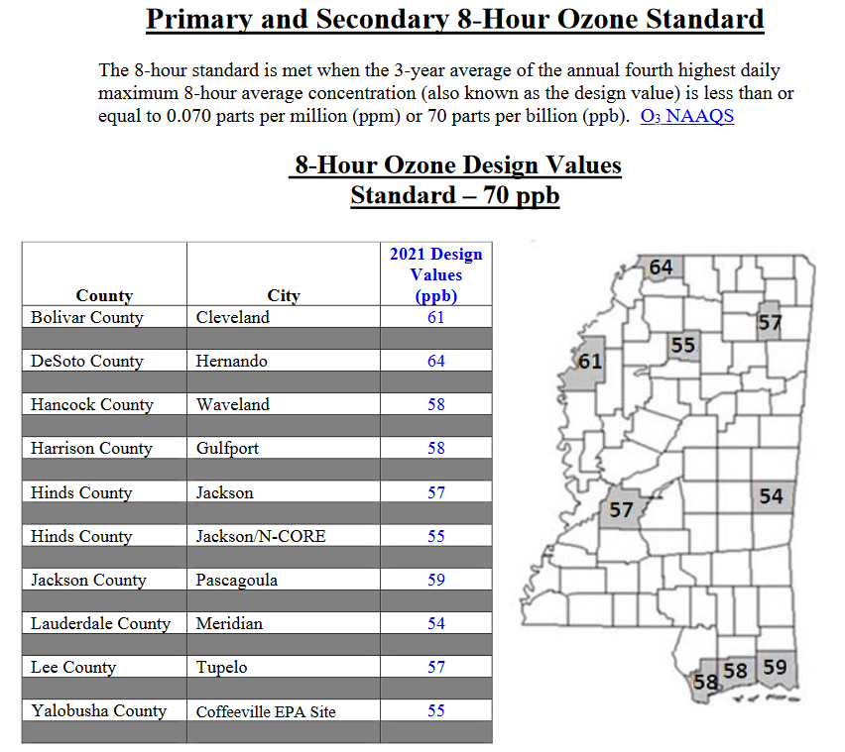
Figure 1 – 2021 8-Hr Ozone Design Values
Source: MDEQ Air Quality Data Summary 2021

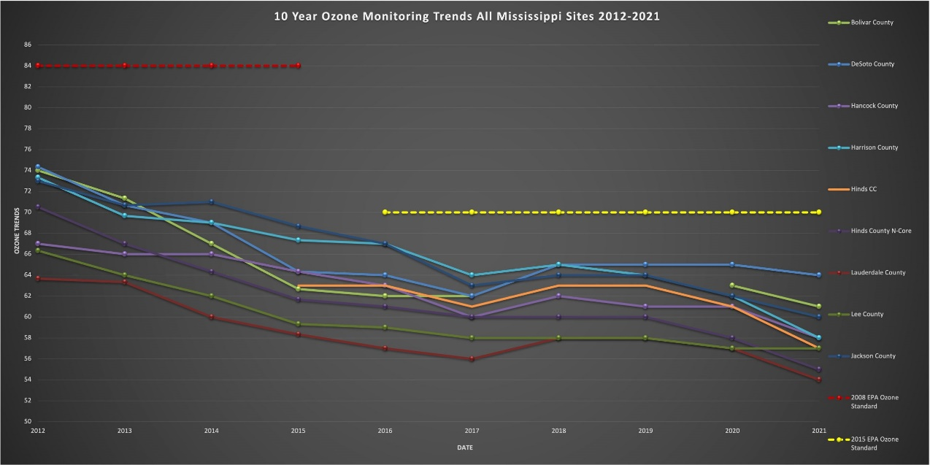
Figure 2 – 10-Year Ozone Trends Scaled
Source: MDEQ Air Quality Ozone Monitoring Results

PSD Preliminary Analysis Modeling Impacts
In the preliminary analysis, only the significant increase in potential emissions of a pollutant from a proposed new source, or the significant net emission increase of a pollutant from a proposed modification is modeled. A full impact analysis for a particular pollutant is not required when emissions of that pollutant from a proposed source or modification would not increase ambient concentrations by more than prescribed significant ambient impact levels.

For the purpose of this proposed modification, the only pollutant with a significant net emissions increase is VOC. Although the EPA has not established a NAAQS for VOCs, it is a precursor to ozone. As discussed in Section B above, the EPA recommends the use of a “two-tiered” approach to address single-source impacts on ozone. The first tier involves the use of existing technical information to evaluate the relationships between precursor emissions and a source’s impacts. The second tier involves the application of more sophisticated, case-specific chemical transport models (CTMs) (e.g. photochemical grid models). Depending upon the results of the first-tier evaluation and if applicable the culpability analysis, the second tier may not be required.
Tier 1 Demonstration for Ozone
The April 30, 2019 Memorandum “Guidance on the Development of Modeled Emission Rates for Precursors (MERPs) as a Tier 1 Demonstration Tool for Ozone and PM_{2.5} under the PSD Permitting Program” reflected the EPA’s recommendations on how to conduct an air quality modeling and related technical analyses to satisfy compliance demonstration requirements for ozone and secondary PM_{2.5} for permit related assessment under the PSD Program. Interfor U.S. Ince. – Bay Springs utilized the MERPs guidance to assess the proposed project impacts on ozone.

For ozone, the modeled air quality impact of an increase in precursor emissions from the hypothetical source is expressed in units of ppb or ppm. Consistent with the modeled emissions rates that are input to the air quality model to predict a change in pollutant concentration, MERPs are expressed as an annual emissions rate in tons per year (tpy). The SIL represents a de-minimis impact level. If the maximum concentration of ozone due to a single source is less than the SIL, then it can be concluded that the source has an insignificant contribution to ozone formation. The most conservative hypothetical source’s modeled emission rate and impacts along with the ozone SIL were used to calculate the MERPs values below:

$$Modeled Air Quality Impact from Hypothetical Source$$

$$=\left(Critical Air Quality Threshold\right)\left(\frac{Modeled Emission Rate from Hypothetical Source}{MERP}\right)$$

$$Modeled Air Quality Impact from Hypothetical Source$$

$$=\left(1ppb ozone\right)\left[\left(\frac{259.1 TPY VOC}{2,307 TPY VOC}\right)+\left(\frac{11.04 TPY NOx}{190 TPY NOx}\right)\right]$$

$$Modeled Air Quality Impact from Hypothetical Source=0.17 ppb ozone$$

The critical air quality threshold equals the ozone SIL of 1 ppb, the project emissions are 259.1 tpy VOCs and 11.04 tpy NO_{X}, and the MERPs are as previously stated. The worst-case ozone increase of 0.17 ppb is well below the ozone SIL, and the project will not cause a significant ambient impact for ozone. Therefore, no further analysis is required.

PSD Full Impact Analysis Modeling Impacts
A full impact analysis is only required for any pollutant for which the proposed source’s estimated ambient pollutant concentrations exceed prescribed significant ambient impact levels. This analysis expands the preliminary analysis in that it considers emissions from: the proposed source; existing sources; residential, commercial, and industrial growth that accompanies the new activity ant the new source or modification. For SO₂, PM₁₀, and NO_{X}, the full impact analysis consists of separate analyses for the NAAQS and PSD increments.

The preliminary analysis results, presented in the section above, demonstrate the combined impacts of the ozone precursors, VOCs and NO_{X}, will not have a significant impact on the 8-hr daily maximum ozone. The proposed project will not cause ozone concentration exceeding the recommended significant impact level for ozone. No further analysis is required.

Vegetation and Soils Impact
VOCs are regulated as precursors to tropospheric ozone. Elevated ground-level ozone concentrations can damage plant life and crop production. VOCs interfere with the ability of plants to produce and store food, making them more susceptible to disease, insects, or other pollutants and harsh weather. Ozone is formed by the interaction of NO_{X}, VOCs, and sunlight in the atmosphere. As the project potential for ozone formation due to emissions from the facility is insignificant, there are no adverse impacts on soils or vegetation anticipated.

Associated Growth Impact
The growth analysis is conducted to estimate increased emissions due to residential, commercial, and industrial growth that will occur as a result of the project. The facility expects to hire 15 new employees in order to achieve increases in production. It is believed that any new employees will already be part of the existing labor force in the surrounding area, therefore, no additional housing or businesses are anticipated to be constructed. It can be determined that no significant residential, commercial, or industrial growth is anticipated as a result of the project.

Class I Impact and Visibility
The Federal Land Managers’ Air Quality Related Values Work Group (FLAG), Phase I Report – Revised (2010), provides recommendations, specific procedures, and interpretation of results for assessing visibility impacts of new or modified sources on Class I Area resources. Section 3.2., Initial Screening Criteria (New), presents a screening tool, Q/D (where Q is the total SO₂, NO_{X}, PM₁₀, and H₂SO₄ annual emissions divided by D, the distance from the Class I Area), to screen out from Air Quality Related Values (AQRV) review for those sources with relatively small amounts of emissions located a large distance from a Class I Area. When using the Q/D screening, it is only required to screen facilities at are within 300km of a Class I area. If Q/D is less than or equal to 10, the source will be considered to have negligible impacts with respect to Class I AQRV. The Federal Land Manager (FLM) (and the Federal official with direct responsibility for management of the Federal Class I parks as wilderness areas) will not request any further Class I AQRV impact analysis. As a minimum, the permitting authority should notify the FLM of all sources that exceed the Q/D criteria.

SO₂ 0.0-tpy
NO_{X} 11.04-tpy
PM₁₀ 13.71-tpy
H₂SO₄ 0.0-tpy

Q/D$=\frac{\left({SO}_{2}+{NO}_{x}+{PM}_{10}+H_{2}{SO}_{4} \right)}{Distance from Class I Area}$

Class I Area | Class I Area Distance (km) | Q/D Value | Agency
Breton National Wildlife Refuge | 246 | 0.1 | Fish & Wildlife Service (FWS)
Caney Creek Wilderness Area | 522 | - | Forest Service (FS)
Mingo Wilderness Area | 564 | - | Fish & Wildlife Service (FWS)
Sipsey Wilderness Area | 315 | - | Forest Service (FS)
Upper Buffalo Wilderness Area | 580 | - | Forest Service (FS)

As seen in the table above, all 5 Class I areas that Mississippi affects are shown, but only the Brenton National Wildlife Refuge Q/D value was calculated, since it the only Class I area within 300km of the facility. Interfor U.S. Inc. – Bay Springs is located approximately 246 km from the Brenton National Wildlife Refuge. The increase of visibility impairing pollutants were below the PSD significant levels, therefore, no Class I impact is necessary.

Class II Impact and Visibility
The Class II Visibility Analysis evaluates the impact the proposed project will have on local visibility conditions. This analysis is based upon impacts within the significant impact area of the proposed project and is separate from the Class I visibility analysis. Components contributing to visibility impairment include sulfates, NO_{X}, PM, organic carbon, soot (elemental carbon), and crustal material.

