Pre-Construction Review

and

Preliminary Determination

of Approval for

Vicksburg Forest Products, LLC – Waltersville Lumber Mill

Facility No. 2780-00004

Technical Review

by

Ivelina Pilgrim

Air Quality Analysis

by

Jacqueline Evans

September 4, 2020

General Information
Vicksburg Forest Products, LLC – Waltersville Lumber Mill, located at 1725 North Washington Street in Vicksburg, Mississippi 39183, 601-429-6444, has submitted a complete air permit application for a Prevention of Significant Deterioration (PSD) Construction Permit in order to install two (2) new indirect-fired, steam-heated dual path lumber drying kilns (Emission Points AK-029 and AK-030), a tandem ring debarker with a small log saw line within the Sawmill Operations (Emission Point AA-006), and one (1) high-efficiency cyclone within the Wood Waste Handling System (Emission Point AA-001) that will replace the existing baghouse and cyclone.
Vicksburg Forest Products manufactures kiln-dried dimensional lumber form softwood and hardwood logs. The facility currently operates a pneumatic wood waste handling system (Emission Point AA-001), a 94.8 MMBTU / hour wood waste-fired boiler (Emission Point AA-002), a sawmill (Emission Point AA-006) and twenty-eight (28) indirect-fired, steam-heated batch lumber drying kilns (Emission Points AK-001 through AK-028).
The MDEQ received the PSD Construction application on July 24, 2020 and subsequent information on August 13, 2020, which included a process description, emissions calculations, a Best Available Control Technology (BACT) Analysis, and a Source Impact Analysis. The proposed project will result in an emissions increase of volatile organic compounds (VOCs) that exceed the applicable significant emissions rate (SER) in Mississippi’s PSD regulations, 11 Miss. Admin Code Pt. 2, Ch. 5, which adopt by reference the EPA’s PSD regulations found in 40 CFR 52.21.

Project Description
Vicksburg Forest Products is proposing to install two (2) indirect-fired, steam-heated dual path lumber drying kilns with a combined dried lumber throughput capacity of 164,114 thousand board-feet per year (MBF / year). Additionally, the facility is proposing to install a tandem ring debarker and a small log saw line as part of the existing sawmill and replace the existing baghouse / cyclone within the pneumatic wood waste handling system with a new high-efficiency cyclone. As a result of the noted installations, the following sources will also be affected: the 94.8 MMBTU / hour wood waste-fired boiler, the sawmill, the truck load-out operations (Emission Point AA-013), and haul roads (Emission Point AA-007). Additionally, as it pertains to the truck load-out operations, the facility will commence transferring dry planer shavings to the truck bin for shipment off-site instead of conveying it to the boiler’s fuel bin silo.
Based on the affected sources for the proposed project, Vicksburg Forest Products employed a hybrid applicability test to determine the overall project-related emissions increases that combines the “actual-to-potential” test for new sources (i.e. the emissions increase is based on the source’s maximum potential capacity) and the “actual-to-projected actual” test for existing sources [i.e. the emissions increase is based on the regular operation of equipment in any one (1) of the (5) years after completing the project]. As part of the actual-to-projected actual test applied to the wood waste-fired boiler and haul roads, the facility proposed excluding a portion of emissions that the unit “could have accommodated” during the consecutive 24-month baseline period [as allowed by 40 CFR 52.21(b)(41)(ii)(c); shown in Table 1]. Based on the corresponding evaluation, it was determined that the emissions to be excluded were unrelated to the proposed project, occurred at a rate in which no applicable limitations were exceeded, and occurred under operating conditions that could be sustained over an acceptable period of time (specifically for the boiler).
As a result of the hybrid applicability test and the “could have accommodated” emissions evaluation, the overall project-related emissions increase only exceeds the SER for VOCs. However, the emissions increase for particulate matter (PM), particulate matter less than 10 microns in diameter (PM₁₀), and particulate matter less than 2.5 microns in diameter (PM_{2.5}) are at least fifty percent (50%) of the threshold for the corresponding SER threshold. As such, under the “Reasonable Possibly Rule” [40 CFR 52.21(r)(6)(vi)], Vicksburg Forest Products will be required to calculate and maintain the annual emission (based on a 12-month calendar year basis) of the three (3) noted pollutants from all sources affected by the proposed project for a period of five (5) years after completing construction.
With the installation / operation of the two (2) noted dual path lumber drying kilns, Vicksburg Forest Products will become a major source of hazardous air pollutant (HAP) emissions. Therefore, through this PSD permitting action, the following regulatory changes will occur at the facility upon construction being certified as complete:
- The wood waste-fired boiler will not be subject to 40 CFR Part 63, Subpart JJJJJJ – NESHAP for Industrial, Commercial, and Institutional Boilers Area Sources and will instead be subject to 40 CFR Part 63, Subpart DDDDD – NESHAP for Major Sources: Industrial, Commercial, and Institutional Boilers and Process Heaters.
- All on-site lumber drying kilns will be subject to 40 CFR Part 63 – NESHAP: Plywood and Composite Wood Products.
- The existing HAP emission limitations established in the Permit to Construct Air Emissions Equipment issued on October 3, 2018 will no longer be applicable.
Table 1. PSD Applicability
Pollutant | Projected Actual / Potential Emissions minus Baseline Actual Emissions  (TPY) | “Could Have Accommodated” Emissions  (TPY) | Total Net Emissions  (TPY) | Significant Emission Rate  (TPY) | Netting Analysis Required?  (Yes/No) | PSD Review Required?  (Yes/No)
PM | 49.24 | 32.82 | 16.42 | 25 | No | No
PM₁₀ | 44.00 | 30.83 | 13.17 | 15¹ | No | No
PM_{2.5} | 28.28 | 18.89 | 9.39 | 10 | No | No
NO_{X}^{1,2} | 33.64 | 21.32 | 12.32 | 40 | No | No
SO₂¹ | 1.31 | 0.22 | 1.09 | 40 | No | No
VOC² | 369.15 | 0.33 | 368.82 | 40 | No | Yes
CO | 46.90 | 5.46 | 41.44 | 100 | No | No
¹ As of April 28, 2011, both NO_{x} and SO₂ are precursors for PM_{2.5}. Therefore, if NO_{x} or SO₂ exceed 40 TPY, the project is considered major for PM_{2.5}.
² Both NO_{X} and VOCs are considered precursors for ozone with a significant emission rate of 40 TPY each.

Best Available Control Technology (BACT) Analysis
In accordance with PSD requirements listed in 40 CFR 51.166(j) and 52.21(j) and 11 Miss. Admin. Code Pt. 2, Ch. 5. Rule 5.1, a facility must apply Best Available Control Technology (BACT) for the control of each regulated air pollutant emitted in significant quantities from a new major stationary source or resulting from a major modification of an existing source located in an attainment area for that pollutant. The proposed project results in an actual-to-potential VOC emissions increase above the VOC significant emissions rate for major modifications, and therefore, this process change is subject to a BACT review for VOC.

The BACT requirements are intended to ensure that a proposed facility or major modification will incorporate air pollution control systems that reflect the latest demonstrated practical techniques for each particular emission unit, and will not result in the exceedance of a National Ambient Air Quality Standard (NAAQS), PSD increment, or other standards imposed at the State level.

Traditional batch lumber kilns are generally equipped with ten (10) to twenty (20) individual roof vents spaced equidistantly following the ridge of the roof. An equal number of vents are located on each side of the kiln roof, and each set of vents reacts in unison during the kiln drying cycle. At any given time, one set of vents allow moisture to exhaust from the kiln while the other set of vents allow dry make-up air to enter
from the atmosphere.

Dual-Path Kilns (DPKs) have no vents and are enclosed structures except for the doors at each end. Each kiln has a double track that allows the lumber packages to travel through the kiln in opposite directions. Steam coils are in the ceiling and vertically along the center of the kilns. Multiple fans are located inside the kilns, and these fans circulate air within the kilns. Each end of the kilns is equipped with a powered vent stack, which draws most of the exhaust to an elevated release to aid in visibility for worker safety.

EPA recommends a “top down” approach when evaluating available air pollution control technologies. The first step in this approach is to determine, for the emission unit in question, the most stringent control available for a similar or identical source or source category. If it can be shown that this level of control is technically or economically infeasible for the unit in question, then the next most stringent level of control is determined and similarly evaluated. This process continues until a control technology and associated emission level is determined that cannot be eliminated by any technical, environmental, or economic objections. The top-down BACT evaluation process is described in the U.S. EPA’s draft document “New Source Review Workshop Manual” (U.S. EPA, October 1990). The five steps involved in a top-down BACT evaluation are:

Step 1. Identify all control technologies;

Step 2. Eliminate technically infeasible or unavailable technology options;

Step 3. Rank the remaining control technologies by control effectiveness;

Step 4. Evaluate the most effective controls and document the results; if the top option is not selected as BACT, evaluate the next most effective control option;

Step 5. Select BACT.

When conducting the BACT analysis, one must include consideration of the most stringent technologies. Any decision to require a lesser degree of emissions reduction must be justified by an objective analysis of energy, environmental, and economic impacts. Furthermore, if a facility is subject to a New Source Performance Standard (NSPS) or National Emission Standards for Hazardous Air Pollutants (NESHAP), the minimum control efficiency to be controlled in a BACT analysis must result in an emission rate less than or equal to the NSPS and/or NESHAP emission rate.

The “top down” approach has been employed in this analysis to evaluate available pollution controls for the proposed process modification.

VOC Analysis
STEP 1 – IDENTIFICATION OF CONTROL TECHNOLOGIES

Available control technologies for the control of VOC emissions were identified through research of the RACT/BACT/LAER Clearinghouse (RBLC), literature review, and surveying of previous applications submitted for continuous kilns. A review of these sources did not reveal any facilities that use add on controls for lumber drying kilns. However, a search was also conducted for VOC control technologies for other processes that could potentially be applied for a lumber dry kiln. The control technologies evaluated are combustion (thermal and catalytic), adsorption, biofiltration, condensation, wet scrubbing, and good work practices.

Combustion: This technology may be applied using different approaches including regenerative thermal oxidation, or catalytic oxidation, boilers, and process heaters. VOC laden air streams are used as fuel sources and high VOC content streams can see destruction efficiencies as high as 99%; depending on the exact characteristic of the incoming air stream and the technology used.

Incineration has been successfully applied to aluminum chip dryers, petroleum processing and marketing operations, animal blood dryers, automotive brake-shoe debonding ovens, citrus pulp dryers, coffee roasters, wire enameling ovens, foundry core ovens, meat smokehouses, paint baking ovens, varnish cookers, paper printing and impregnating installations, pharmaceutical manufacturing plants, sewage disposal plants, chemical processing plants, and textile finishing plants.

Thermal or Catalytic Oxidation: Recuperative Catalytic Oxidizers (RCO) and Regenerative Thermal Oxidizers (RTO) would be considered technically infeasible for controlling VOC emissions from lumber kilns due to various factors. In order to achieve a desired destruction efficiency, a temperature of 1500 °F is required for the RTO and a temperature between 500°F and 800°F is required for the RCO. The temperature of the kiln exhaust is too low for the proper operation of these controls. Furthermore, the resinous nature of the VOCs released during the drying operation inside the kilns would cause issues with the duct work and the catalyst media over time.

Carbon Adsorption: Carbon adsorption systems can be used to remove VOC from exhaust gas streams. This technology would also be considered technically infeasible because the high moisture content of the kiln exhaust and its resinous nature would reduce the capacity and efficiency of the carbon. At high moisture contents, the water molecules and VOCs in the exhaust will compete for the adsorption site, thus reducing the efficiency of the adsorption system.

Condensation: Condensation requires that the exhaust stream be cooled to a low enough temperature to allow for the VOC to go from a gas phase to liquid phase. The primary constituents of the VOC in the exhaust from lumber kilns are terpenes. The temperature of the exhaust stream would have to be lowered to well below 0 °F in order to have a low enough vapor pressure to use condensation. Temperatures this low would cause the water vapor in the stream to freeze, and the ice would clog the unit. As such, condensation is not a technically feasible control technology.

Biofiltration: Biofilters can operate in temperatures between 77°F and 130°F. At a higher temperature, the cell components can decompose and biofilters stop absorbing VOCs. In cases of extreme temperatures, cell components can begin to decompose and proteins within enzymes can become denatured and ineffective. The temperature of the exhaust stream from the kilns will be approximately 150°F, which exceeds the typical operational temperature of biofilters. Due to the temperature requirement and the unproven ability of biofiltration to remove VOCs from lumber kiln emissions, this control technology is considered technically infeasible.

Wet Scrubbing: VOCs present in the kiln exhaust, like α-pinene, are very slightly soluble in water. Lower solubility VOCs would require much longer residence time within a scrubber packed column and would eliminate this as a technically viable solution for the constant stream created by a continuous kiln. Also, this control would create disruption in the air flow. A vacuum blower would be necessary to route kiln emissions to the wet scrubber. The installation of a vacuum blower would affect the temperature and moisture content of the kiln atmosphere and degrade the quality of the lumber product. Therefore, wet scrubbing for VOC removal is not a technically feasible application for drying kilns.

Proper Design and Operation: Proper maintenance and operating practices are comprised of work practice and operational standards and recordkeeping and reporting requirements. The establishment of these good operating practices is intended to minimize VOC emissions from the kilns to the extent practicable. This method involves no add-on pollution controls. However, written procedures of best management practices, proper maintenance and operating activities can be an effective abatement technique when combined with training of employees and appropriate recordkeeping.

Vicksburg Forest Products is proposing an annual BACT emission limit based on an emission factor of 4.43 pounds VOC per thousand board feet (MBF) and a combined production capacity of 164,114 MBF per year for the two (2) steam-heated dual path lumber kilns (Emission Points AK-029 and AK-030).

STEP 2 – Control Technologies Eliminated Based on Feasibility

Thermal Oxidation and Catalytic Oxidation: Thermal oxidation is typically done with a regenerative thermal oxidizer (RTO). To achieve destruction and removal efficiency greater than 90%, a temperature of approximately 1500 °F is required and a minimum residence time of at least one second are required. The exit temperature from the kiln would be well below this required temperature. Furthermore, the resinous nature of the VOCs released during the drying operation inside the kiln would cause issues with the duct work and media in the device over time. Due to the high moisture content, resinous characteristics of the VOCs released and low exit temperature in the exhaust stream, thermal oxidation technology is technically infeasible to be used in this process.

Oxidation can also be achieved with a Regenerative Catalytic Oxidizer (RCO). The required temperature to achieve the desired destruction efficiency inside the RCO is 500-800°F. Even though the temperature is lower than required for an RTO, it is still higher than the typical temperature from the kiln exhaust. As with the RTO, the resinous nature of the VOCs released during the drying operation would create fouling issues in the duct work and the catalyst media. Catalytic oxidation is therefore technically infeasible to be used in this process.

Adsorption: Activated carbon can be used to adsorb the VOC in into the activated carbon substrate. However, the high moisture content of the exhaust and its resinous nature would reduce the capacity and efficiency of the carbon. At high moisture content, the water molecules and the VOC in the exhaust stream would compete for active adsorption site, rendering the system ineffective. Therefore, this control device is technically infeasible to be used in this process.

Condensation: Condensation requires that the exhaust stream be cooled to a low enough temperature to allow for the VOC to go from a gas phase to liquid phase. The primary constituent of the VOC in the exhaust stream from the lumber kilns is terpenes, which would require the temperature of the exhaust stream to be lowered to well below 0 °F in order to have a low enough vapor pressure to use condensation. Temperatures this low would cause the water vapor in the stream to freeze, and the ice would clog the unit. As such, condensation is not a technically feasible control technology.

Biofiltration: Microbial activity within the filter media is readily affected by temperature conditions. Mesophilic conditions (25-40 ºC) are ideal for biofiltration operations and most biofilters consequently operate in ambient temperatures. Some microbes are known to function effectively in thermophilic conditions (40-55 ºC). In cases of extreme temperatures, cell components can begin to decompose and proteins within enzymes can become denatured and ineffective. The temperature of the exhaust stream from the kilns will be approximately 150 °F (65 ºC), which exceeds the typical operational temperature of biofilters.

The primary constituent of the VOC in the exhaust stream is terpenes, which are highly viscous and would cause the biofilter to easily foul. Because of the nature of the long-chained hydrocarbons in the exhaust stream, a biofilter with a reasonable footprint/retention time, will have a reduced control efficiency. The microorganisms require a much longer retention time/size of a unit to provide an increased efficiency.

No installations of biofilters in lumber mills are known. Application of biofiltration technology for VOC removal from lumber kiln emissions has not been demonstrated. Due to the temperature requirement, the large land requirement, and the unproven ability of biofiltration to operate successfully for VOC removal from lumber kiln emissions, this control technology is considered technically infeasible.

Wet Scrubbing: While some VOCs that will be present in the exhaust stream are highly soluble in water, other VOCs, most notably α-pinene, are only very slightly soluble in water. Lower solubility VOCs would require much longer residence time within a scrubber packed column and would eliminate this as a technically viable solution for the constant stream that would need to be handled by a continuous kiln. Wet scrubbing for VOC removal is also technically infeasible for application in drying kilns due to the disruption in air flow created by this type of add-on control. A vacuum blower would be necessary to route kiln emissions to the wet scrubber. The installation of a vacuum blower would affect the temperature and moisture content of the kiln atmosphere and degrade the quality of the lumber product.

STEP 3 – Ranking of Control Technologies

Since all add on control devices have been demonstrated to be technically infeasible for the kilns, proper kiln design and operation remains the only feasible option for control of VOC emissions.

STEP 4 – EVALUATE MOST EFFECTIVE CONTROL(S)

Based on the top-down BACT analysis, the facility has determined proper kiln design, maintenance, and good operating practices are only feasible options, that are both technically and economically sound. A search of the RACT/BACT/LAER database for the 2010-2020 showed a range of limits or basis for limits between 3.5 and 5.8 pounds / MBF of VOC. The variability is due in part on how the VOC determination was made, how the VOC is expressed, whether the value has been corrected by adding formaldehyde and methanol as well as the variation in VOC content of lumber throughout the year, based on temperature and moisture content.

STEP 5 – SELECT BACT

Vicksburg Forest Products is proposing an annual BACT emission limit based on an emission factor of 4.43 pounds VOC per thousand board feet (MBF) and a combined production capacity of 164,114 MBF per year for the two (2) steam-heated dual path lumber kilns. The facility will also follow an initial operation maintenance plan as outlined below:

1. Operation of the kilns in accordance with manufacturer’s recommendations;

2. Routines for preventative maintenance will be as detailed in a monitoring plan based on manufacturer’s recommendations. The plan will at a minimum identify the frequency of maintenance for the following activities:

- Walk around inspection;

- Wet bulb proper operation;

- Entrance/exit baffles inspection;

- Grease kiln cart wheels and fan shaft bearings;

- Check hydraulic oil levels;

- Calibration of moisture content equipment; and

- Temperature probe calibration.

Source Impact Analysis
The owner or operator of a proposed source or modification is required to demonstrate that allowable emission increases from the proposed source or modification, in conjunction with all other applicable emissions increases or reductions (including secondary emissions), will not cause or contribute to air pollution in violation of: 1) any national ambient air quality standard in any air quality control region; or 2) any applicable maximum allowable increase over the baseline concentration in any area. NAAQS exist for Carbon Monoxide (CO), Lead (Pb), Nitrogen Dioxide (NO₂), Ozone (O₃), Particle Pollution (PM_{2.5} and PM₁₀) and Sulfur Dioxide (SO₂). PSD Increments exist in areas designated as Class I, II or III for PM_{2.5}, PM₁₀, SO₂ and NO₂. There are no NAAQS nor PSD Increment for Volatile Organic Compounds (VOC).
The modeled concentrations used to determine compliance with any NAAQS and PSD increment depend on 1) the type of standard, i.e., deterministic or statistical, 2) the available length of record of meteorological data, and 3) the averaging time of the standard being analyzed. When the analysis is based on 5 years of National Weather Service meteorological data, the following estimates are used:
- For deterministically (i.e., not to be exceeded more than once per year) based standards (e.g., CO, SO₂), the highest, second-highest short term estimate and the highest annual estimate; and
- For statistically based standards (e.g., PM₁₀), the highest, sixth-highest estimate and highest 5-year average estimate.

Existing Air Quality
Any application for a permit under the Prevention of Significant Deterioration program is required to contain an analysis of ambient air quality in the area that the major stationary source or major modification would affect for each of the following pollutants: a) for the source, each pollutant that it would have the potential to emit in a significant amount; b) for the modification, each pollutant for which it would result in a significant net emissions increase.
The existing air quality is defined by the natural and human-generated sources of air pollution. The area surrounding the Warren County facility is considered rural and in attainment for all regulated pollutants. The pollutants under consideration in the analysis are volatile organic compounds (VOC).

Modeling Procedure
All estimates of ambient concentrations are to be based upon applicable air quality models, databases and other requirements specified in appendix W of 40 CFR Part 51 (Guideline on Air Quality Models).
The EPA Memorandums, “Guidance on the Development of Modeled Emission Rates for Precursors (MERPs) as a Tier I Demonstration Tool for Ozone and PM2.5 under the PSD Permitting Program,” dated April 30, 2019, and “DRAFT Guidance for Ozone and Fine Particulate Matter Permit Modeling” dated February 10, 2020 reflect EPA’s recommendation for how agencies conduct air quality modeling and related technical analyses to satisfy compliance demonstration requirements for ozone and PM_{2.5} under the PSD Permitting Program. In accordance with the above-mentioned Guidance and the Revisions to the Guideline on Air Quality Models (40 CFR Part 51, Appendix) EPA recommends that an applicant use a “two-tiered” demonstration approach to address single-source impacts on ozone and secondary PM_{2.5}. The first tier involves the use of existing technical information to evaluate the relationships between precursor emissions and a source’s impacts. The second tier involves the application of more sophisticated case-specific chemical transport models (CTMs) (e.g., photochemical grid models).
The PSD requirements for a compliance demonstration only apply to regulated NSR pollutants that would be emitted in a significant amount. The emissions of individual Ozone precursors/pollutants (i.e., NOx and VOC) are not summed when determining a significant emissions increase. Only the component of Ozone that would by themselves be emitted by a new or modifying source in a significant amount would be included in the air quality analysis. EPA’s MERPs VIEW Qlik application (https://www.epa.gov/scram/merps-view-qlik) provides easy access to EPA’s hypothetical single source modeled impacts of Ozone and PM_{2.5}to support appropriate PSD applications – the Class II NAAQS Tier 1 demonstrations for PSD permits, illustrative hypothetical single source modeled impacts for annual and daily maximum average PM_{2.5} and annual maximum daily 8-hr Ozone (information provided as MERPs).
Should the Tier I Demonstration find the critical air quality threshold would not be exceeded when considering the impact of the Ozone precursor emissions of VOC on the 8-hr daily maximum ozone; the proposed project will not cause ozone concentrations exceeding the ozone SIL. No further analysis needed. No additional modeling required.

Air Quality Monitoring Requirements
The ambient air quality analysis is required to contain continuous air quality monitoring data gathered for purposes of determining whether emissions of that pollutant would cause or contribute to a violation of the standard or any maximum allowable increase. The source may be exempt from the preconstruction monitoring requirements if the air quality impacts are less than the monitoring de minimis concentrations.
Table 1. Preconstruction de minimus levels
Pollutant | Averaging Period | Monitoring  de minimis Concentration (µg/m3) | Modeled Concentration (µg/m3)
Ozone^{(a)} | - | VOC or NOx emission increase < 100-tpy | 369-tpy VOC  13.33-tpy NOx
(a) No de minimus air quality level is provided for ozone. However, any net emissions increase of 100-tpy or more of VOC or NOx subject to PSD would be required to perform an ambient impact analysis, including the gathering of ambient air quality data

The preliminary analysis results for ozone exceed the applicable monitoring de minimis concentration; therefore, preconstruction monitoring is required. If either the predicted modeled impact from an emission increase or the existing ambient concentration is less than the monitoring de minimis concentration, MDEQ has the discretionary authority to exempt an applicant from pre-construction ambient monitoring. No de minimis air quality level is provided for Ozone. However, any net emissions increase of 100-tpy or more of volatile organic compounds or nitrogen oxides subject to PSD would be required to perform an ambient impact analysis, including the gathering of ambient air quality data. Pre-construction monitoring of ozone can be waived if representative data for the area is available. MDEQ monitors this pollutant at several monitors across the state. Existing ambient air monitoring for this pollutant will be used in lieu of conducting preconstruction monitoring.
Ozone – Jackson Metro (Hinds County CC AQS ID 28.049.0021)
Vicksburg Forest Products proposes to use the existing air quality monitor located at 3925 Sunset Dr., in Jackson, MS. The Hinds County Ozone monitor is located approximately 48 miles east of the Vicksburg Forest Products, LLC – Waltersville Mill facility. The area surrounding the Warren County facility is rural. The site location of the Hinds County monitor is considered neighborhood/urban. The population of Warren County is approximately 45,381 with a population density of 79/sq. mile. The population of Hinds County is approximately 231,840 with a population density of 110/sq. mile. Warren County and Hinds County have emissions of VOC along the same order of magnitude and both counties have similar quantities of VOC emissions generated by naturally occurring events (See Figure 1). Given the population difference and the similar distribution of emissions by sector, the Jackson Metro – Hinds County monitor would be a conservative estimate of the air quality at the facility.
The 8-hr Standard is met when the 3-yr average of the annual fourth highest daily maximum 8-hr average concentration (also known as the design value) is less than or equal to 0.070 parts per million (ppm) or 70 parts per billion (ppb). The MDEQ 2019 Air Quality Data Summary indicates the design value for the Hinds County – Jackson monitor is 63 ppb. The monitored area is in attainment with the 8-hr ozone standard. The ozone data is representative of the air quality in the vicinity of the project; therefore, existing monitoring data is used in lieu of performing preconstruction monitoring.
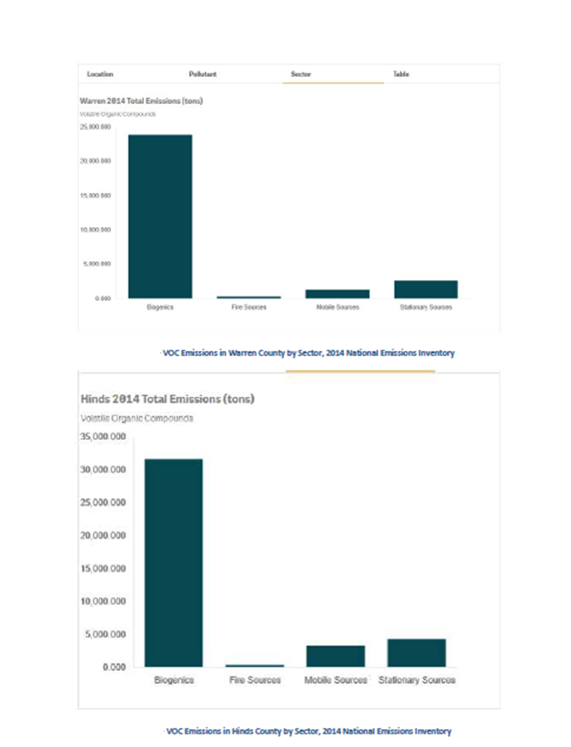
Figure 1 - 2014 NEI VOC Emissions by County, All Sectors
Ozone Ambient Impact Analysis
No de minimis air quality level is provided for Ozone. However, any net emissions increase of 100-tpy or more of volatile organic compounds or nitrogen oxides subject to PSD would be required to perform an ambient impact analysis, including the gathering of ambient air quality data.
Ozone is a gas composed of three atoms of oxygen. Ozone occurs both in the Earth’s upper atmosphere and at ground level. Ground level Ozone occurs naturally in lower amounts and additional ozone is formed when nitrogen oxides (NOx) and VOC react chemically in the presence of sunlight. Emissions from cars, industrial facilities, electric utilities, refineries, and chemical plants are some of the major sources of NOx and VOC emissions. Because, this reaction takes time to occur, ozone is usually formed downwind of emission sources.
MDEQ collect and evaluate ozone data from various monitoring sites located in Mississippi. This data is compared to the current 8-hour National Ambient Air Quality Standard (NAAQS) for Ozone to determine how the state is doing in meeting this standard. As presented in the “Mississippi Department of Environmental Quality 2019 Air Quality Data Summary” report, Mississippi remains in attainment for all NAAQS.
Ozone Standard
There is one primary and secondary ozone standard – the 8-hour average. MDEQ monitors ozone continuously from March 1 through October 31 each year at the monitoring sites listed below. Ozone is monitored year around at the N-CORE site located in the Jackson MSA.
Primary and Secondary 8-Hour Ozone Standard
The 8-hour standard is met when the 3-year average of the annual fourth highest daily maximum 8-hour average concentration (also known as the design value) is less than or equal to 0.070 parts per million (ppm) or 70 parts per billion (ppb).

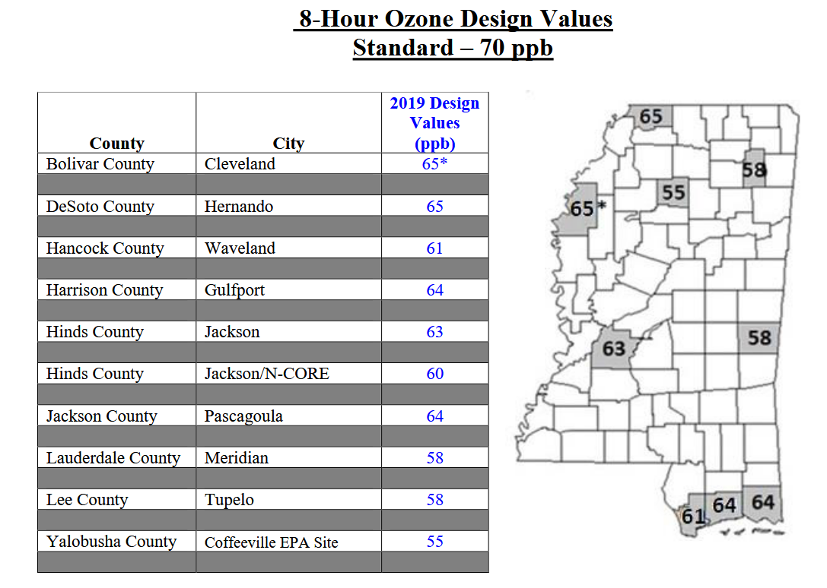
Figure 2 – 2019 8-Hr Ozone Design Values

Regional Trends in Ozone

Using a nationwide network of monitoring sites, EPA has developed ambient air quality trends for ozone. The blue band shows the distribution of ozone levels among the trend sites. The white line represents the average among all trend sites. The South Regional trends for the 8-hr ozone standards are depicted in Figure 3 below.
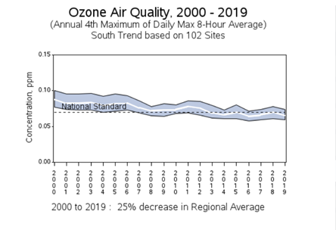
Figure 3 - Ozone Air Quality South Regional Trends 2010-2019

Air Quality trends can vary regionally. The contiguous United States comprise nine (9) climatically consistent regions. Mississippi is contained in the South Region. From 2000 to 2019, South Regional Trends have shown a 25% decrease in the Regional Average.

PSD Preliminary Analysis Modeling Impacts
In the preliminary analysis, only the significant increase in potential emissions of a pollutant from a proposed new source, or the significant net emission increase of a pollutant from a proposed modification is modeled. A full impact analysis for a particular pollutant is not required when emissions of that pollutant from a proposed source or modification would not increase ambient concentrations by more than prescribed significant ambient impact levels.
Tier 1 Demonstration for Ozone
In accordance with the Revisions to the Guideline on Air Quality Models (40 CFR Part 51, Appendix W) EPA recommends that an applicant use a “two-tiered” demonstration approach to address single-source impacts on ozone and secondary PM_{2.5}. The first tier involves the use of existing technical information to evaluate the relationships between precursor emissions and a source’s impacts. The second tier involves the application of more sophisticated case-specific chemical transport models (CTMs) (e.g., photochemical grid models). The April 30, 2019 Memorandum, “Guidance on the Development of Modeled Emission Rates for Precursors (MERPs) as a Tier 1 Demonstration Tool for Ozone and PM_{2.5} under the PSD Permitting Program”, and the “DRAFT Guidance for Ozone and Fine Particulate Matter Permit Modeling”, dated February 10, 2020 reflected EPA’s recommendations on how to conduct an air quality modeling and related technical analyses to satisfy compliance demonstration requirements for Ozone and Secondary PM_{2.5} for permit related assessment under the PSD Program.
The PSD requirements for a compliance demonstration only apply to regulated NSR pollutants that would be emitted in a significant amount. The emissions of individual Ozone precursors/pollutants (i.e., NOx and VOC) are not summed when determining a significant emissions increase. Only the component of Ozone that would by themselves be emitted by a new or modifying source in a significant amount would be included in the air quality analysis. The Vicksburg Forest Products LLC – Waltersville Mill, utilized the MERPs guidance to assess the proposed project impacts on ozone.
The project source is not located in an area with unusual circumstances regarding complex terrain, proximity to very large sources of NOx or VOCs, or meteorology. Therefore, the most conservative illustrative MERP value may be considered adequately representative to characterize the responsiveness of ozone to precursors emitted in a region or area. Table 4-1 of the MERPs guidance, summarizes the distribution of illustrative MERPs values across climate zones showing lowest, highest and median values. Mississippi is located in the South Climate Zone. The lowest 8-hr ozone MERP values from VOC for the South Climate Zone is 2,307-tpy.
For Ozone, the modeled air quality impact of an increase in precursor emissions from the hypothetical source is expressed in units of ppb or ppm. Consistent with the modeled emissions rates that are input to the air quality model to predict a change in pollutant concentration, MERPs are expressed as an annual emissions rate in tons per year (tpy).
The recommended ozone SIL of 1-ppb was chosen to represent the critical air quality threshold. The SIL represents a de-minimis impact level, that is, if the maximum concentration of ozone due to a single source is less than the SIL, then it can be concluded that the source has an insignificant contribution to ozone formation. The most conservative hypothetical source’s modeled emission rate and impacts along with the ozone SIL were used to calculate the MERPs values below:
VOC MERP = 2,307-tpy
To assess the additive secondary impacts on the 8-hr daily maximum ozone, the following equation was used:
Modeled air quality impact = (Critical Air Quality Threshold)(Project Emissions/MERPs)
= (1 ppb)(369 tpy/2,307 tpy)
= 0.16 ppb
The Modeled Air Quality Impact is below the Ozone significant impact level. The proposed project will not cause ozone concentrations exceeding the recommended significant impact level for ozone. No further analysis is required.

PSD Full Impact Analysis Modeling Impact
A full impact analysis is required for any pollutant for which the proposed source’s estimated ambient pollutant concentrations exceed prescribed significant ambient impact levels. This analysis expands the preliminary analysis in that it considers emissions from: the proposed source; existing sources; residential, commercial, and industrial growth that accompanies the new activity ant the new source or modification. For SO₂, PM₁₀, and NO₂, the full impact analysis actually consists of separate analyses for the NAAQS and PSD increments.
The preliminary analysis results presented in Section D above, demonstrates the combined impacts of the ozone precursors, VOC and NOx, will not have a significant impact on the 8-hr daily maximum ozone. The proposed project will not cause ozone concentration exceeding the recommended significant impact level for ozone. No further analysis is required.

Vegetation and Soils Impact
Vicksburg Forest Products, LLC – Waltersville Mill is required to provide an analysis of the impairment to visibility, soils and vegetation that would occur as a result of the source or modification. However, Vicksburg Forest Products need not provide an analysis of the impact on vegetation having no significant commercial or recreational value.
The secondary NAAQS are set to “protect the public welfare from any known or anticipated adverse effects” associated with ambient concentrations of the pollutant. The term “welfare” is defined in the Clean Air Act to include “effects on soils, water, crops, vegetation, man-made materials, animals, wildlife, weather, visibility, and climate”. The modeled results were below the secondary NAAQS and, therefore, no adverse impact on soils and vegetation is anticipated.
VOCs are regulated as precursors to tropospheric ozone. Elevated ground-level ozone concentrations can damage plant life and crop production. VOCs interfere with the ability of plants to produce and store food, making them more susceptible to disease, insects, or other pollutants and harsh weather. Ozone is formed by the interaction of NOX, VOC, and sunlight in the atmosphere. As the project potential for ozone formation due to emissions from the facility is insignificant, no adverse impacts on
soils and vegetation is anticipated.

Associated Growth Impact
Vicksburg Forest Products, LLC – Waltersville Mill is required to provide an analysis of the air quality impact projected for the area as a result of general commercial, residential, industrial and other growth associated with the source or modification. Based on Vicksburg Forest Products’ analysis, there will be a minimal increase in the work force due to the project. The fifty (50) new employees expected to be hired will be selected from the existing workforce in the area. No additional demand on housing or public utilities is expected. No growth due to support facilities is anticipated.

Class II Visibility
The Class II Visibility Analysis evaluates the impact the proposed project will have on local visibility conditions. This analysis is based upon impacts within the significant impact area of the proposed project and is separate from the Class I visibility analysis. Components contributing to visibility impairment include sulfates, NOx, PM, organic carbon, soot (elemental carbon), and crustal material.
No protected vistas or other sensitive areas were identified near the Vicksburg Forest Products, LLC – Waltersville Mill. No significant visibility impairment is expected. No further analysis needed.

Class I Impact and Visibility
The proposed facility is located approximately 380 km from the Sipsey Wilderness Area and 350 km from the Breton Wilderness Area. Due to the distance and the proposed emission rates, no adverse impacts at the Class 1 areas are anticipated.

Recommendation
The impacts of the emission of air pollutants from the proposed project have been evaluated and the staff believes that, with proper constraints and limitations, this project will operate within all State and Federal air pollution control laws and standards and will be protective of public health and welfare. Therefore, the staff of the Board has preliminarily decided, based on available information, to recommend to the Board that the permit be issued to reflect the requested construction of emissions equipment. However, before proceeding further with the staff evaluation, public comments are being solicited. The staff recommendation to the Board, as well as the Board decision, will be made only after a thorough consideration of all public comments.

